**Homework 8: Sensor Essay**

Hearing is a vital sense that allows us to communicate with each other through sound waves, that is, vibrational oscillations throughout the air at different frequencies. Evolutionarily, it has allowed us to sense and detect dangers, allowing us to survive and reproduce. It makes sense that a sense with such an important functionality would have a complicated mechanism; there are many components, starting from the outer ear, that allow us to capture and process sound waves. Although most people have this innate sense from their birth, others are not so fortunate; for a variety of reasons, these individuals lose their ability to hear. For some, this hearing loss can be solved with a specific biosensor: the cochlear implant.

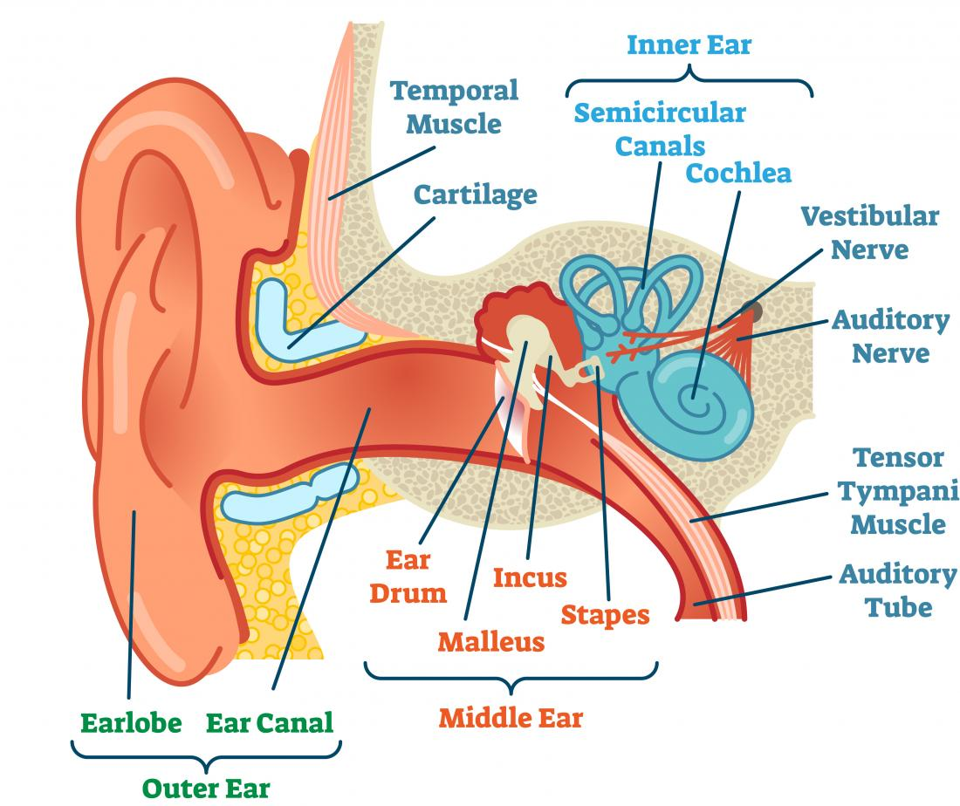

Figure 1: Sections of the ear [1]

To understand the drive and reason behind the cochlear implant, we must first briefly discuss the complicated mechanisms behind hearing. The ear can be subset into three regions: the outer ear, the middle ear, and the inner ear; our focus is on the inner ear [1]. The outer ear serves as an external region to capture as much sound as possible. After the waves make it into the ear canal and into the middle ear, they are amplified via the eardrum. The vibration of the eardrum triggers oscillation movement, allowing for sound to be amplified and propagated to the next section of the ear. This amplified sound (a vibration) enters the inner ear, which begins with the cochlea. This small curled tube is filled with liquid, and has a basilar membrane consisting of many small hairs. Vibrations coming from the earlier parts of the ear cause the fluid to move, and specific locations and amounts of hairs to vibrate, based on the pitch and amplitude of incoming sound. When these hairs move, they open up ion channels via their bent stereocilia, causing a signal to be sent to the brain; this signal is sent through the auditory nerve and to the medulla [1].

For those with hearing loss, multiple solutions exist. In mild cases, hearing aids can be used to amplify sounds in the middle ear so that sound waves can more easily be detected in the cochlea. However, for more extreme cases of hearing loss involving the inner ear, such as malfunctioning amplification or defects to the structure of the cochlea, hearing aids cannot offer help. Instead, the cochlear implant is used. The cochlear implant is a small electrical sensor, with an external and internal portion (with respect to the head), like the outer/inner configuration of the ear; it is made up of the internal components (collectively called the “implant”), and the external components [2]. The cochlear implant works well for people with damaged inner ear systems, because it bypasses most of the mechanisms naturally used in the ear; rather than amplifying sound, it sends electrical signals directly to the auditory nerve, after they are digitally encoded [3].

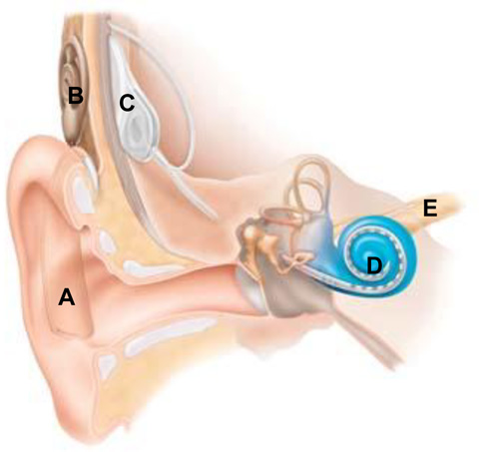

Figure 2: Cochlear Implant [3]

The cochlear implant is made up of several primary components. First, there is a sound processor (A), which captures sound, converting the analog signal into a digital code [3]. It acts as a microphone, detecting different noises, and includes a battery (that the entire system utilizes). After the analog-digital converter creates a digital signal, it is sent via the coil (B) to the implant (C). Note that the coil rests on the outside of the skin, while the implant is under (surgically placed). Finally, this digital signal propagates through the wire to an electrode array (D) located in the cochlea. The stimulation of these electrodes in the inner ear cause auditory nerve stimulation, allowing for sound to be heard, and the electrical discrete signal to be converted into a continuous biological one. The cochlear implant therefore acts as an analog to digital converter, allowing for sounds to be converted and sent to the ear. Then, the ear acts as a digital to analog converter, converting these electrical signals back to perceived sounds in the brain via electrochemical signaling. The cochlear implant also performs some signal processing before converting it to digital, to prevent unwanted noises from coming through (it acts as a filter of certain frequencies, attenuating them, and allowing a passband region through).

Although the cochlear implant seems perfect in practice, there are many factors to consider before deciding to go through with one. First, the placement of the implant via the incision of the skin requires ‘delicate’ surgery – the middle and inner ear are sensitive [3]. In addition, with the addition of cochlear implant, there is a risk to lose any residual hearing that existed before. This means that the cochlear implant would be the only way to hear after the procedure [4]. After the procedure, training is required to understand and process noises that come through the device – it might take practice to recognize everyday noises, as they will sound different with the implant. However, most of the rehabilitation can be alleviated by starting the procedure at an early age. Children will naturally develop better hearing and speech at a younger age. Finally, some studies have suggested that adults who have “little or no experience of sound” benefit less from the implant [4].

In conclusion, the cochlear implant is an important sensor that aids people with hearing problems and helps them hear again. On the outside of the head, it acts like a microphone, receiving and filtering signals, and converting them to digital signals. After these digital signals are sent to an electrode in the cochlea, the auditory nerve is stimulated via the cochlea movement, and the brain perceives sound. Thus, the whole process successfully converts analog to digital to analog sound signals, from the outside environment to the brain.

**References**

[1] “Ears and hearing: How do they work?,” *Medical News Today*. [Online]. Available: https://www.medicalnewstoday.com/articles/321179.php. [Accessed: 13-Jun-2019].

[2] “Cochlear Implants,” *NIDCD*, 18-Aug-2015. [Online]. Available: https://www.nidcd.nih.gov/health/cochlear-implants. [Accessed: 13-Jun-2019].

[3] “Cochlear implants,” *Hearing Link*. [Online]. Available: https://www.hearinglink.org/your-hearing/implants/cochlear-implants/. [Accessed: 13-Jun-2019].

[4] “Cochlear implants - Mayo Clinic.” [Online]. Available: https://www.mayoclinic.org/tests-procedures/cochlear-implants/about/pac-20385021. [Accessed: 13-Jun-2019].